**VIT UNIVERSITY**

Internet And Web Programming – Project

(Under the guidance of Sir Jayakumar K)

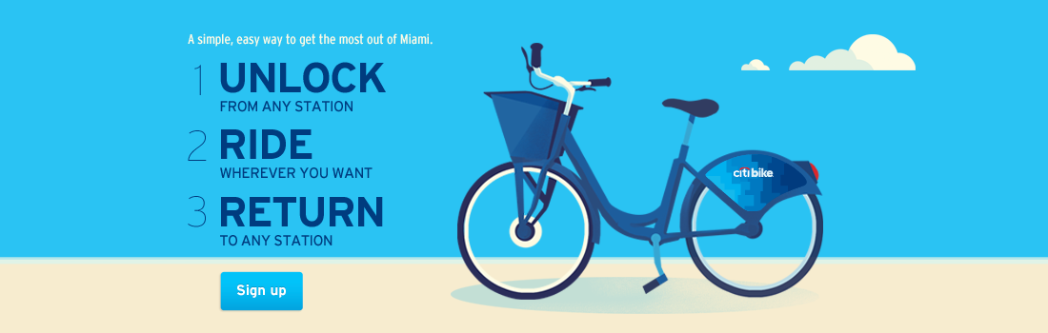

“**The Bike Rental System**”

Project Abstract for CSE3002

Submitted by

**Samriddhi Singh – 17BCE2138**

**Arijit Roy – 17BCE0392**

**Niyati Sahani– 17BCE0506**

# Abstract:

“The Bike Rental System” is designed to help the customers to take bikes or two-wheelers on rent. There are many people in this world who don’t need their own vehicle, as for them, maintaining a vehicle is not manageable and thus they prefer not to own a vehicle. Our system deals with the exactly same people, it allows them to rent a vehicle with freedom and flexible charges.

**How does our system work?**

* Any user who wish to rent a bicycle must register to our website and make payment accordingly.
* After the payment is done, an OTP will be generated and will be send to the registered mobile number.
* This OTP will be used to unlock the vehicle from the bike station.
* Once unlocked, the person can ride the bicycle .

**Important Features:**

* **Account Creation**(Sign up and Login): User can create their account and login
* **Payment**: User needs to make necessary payment for renting the bicycle.
* **GPS tracking System**: Users can track the Location of other users
* **Messaging System**: Since there will be limited number of bicycles, there can be a situation when a user has to wait for other users to give back the bicycle. In such a situation, users can contact each other.
* **Feed-back system**

# **Technical Aspects of the Project:**

* Website creation using **HTML5**
* Website design and presentation using **CSS3**
* Validation using **Javascript/JQuery**
* Business Logic implementation using **NODE JS**
* Database Design using **MONGO DB**
* Asynchronous Page using **AJAX**
* Latest Technology using **REACT and REDUX**